**Phone : 0755-2529015,016,026 057,159**

**Fax : 0755-2529472**

**E-mail :** [**oistbpl@oriental.ac.in**](mailto:oistbpl@oriental.ac.in)

**Web. : www.oriental.ac.in**

**ORIENTAL INSTITUTE OF** SCIENCE & **TECHNOLOGY**

(EX, ME, EC, CSE, CE) Programs are Accredited by National Board of Accreditation (NBA), New Delhi Approved by AICTE, New Delhi & Govt. of M.P.

Affiliated to Rajiv Gandhi Proudyogiki Vishwavidyalaya, Bhopal

Oriental Campus, Opp. Patel Nagar, Raisen Road, Bhopal - 462 022 (M.P.) INDIA

**Ref : OIST/2024-25/July /GRPC2970 Date : 10-07-2024**



This is to certify that Mr. Vinit Dubey S/o Mr. SATISH KUMAR DUBEY is a regular Student of B. Tech (CSE Artificial Intelligence and Machine Learning) VII Semester (Roll No. 0105AL211137) in this Institute. This Certificate issued to the above student on his request to enable him to apply for Identity Proof.

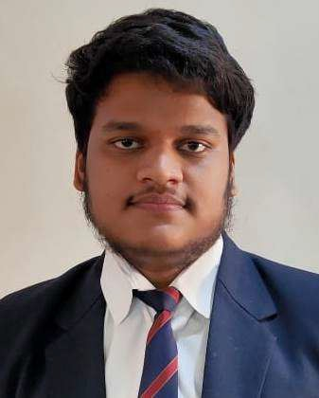

**Director/Principal**